**Course: 305-02: Mobile Application Development – 1**

**Unit-5: Android Widgets (UI)**

[5.1 Hiding Title bar](https://www.javatpoint.com/android-hide-title-bar-example)

### **Android Hide Title Bar and Full Screen Example**

In this example, we are going to explain how to hide the title bar and how to display content in full screen mode.

The **requestWindowFeature(Window.FEATURE_NO_TITLE)** method of Activity must be called to hide the title. But, it must be coded before the setContentView method.

Code that hides title bar of activity

The getSupportActionBar() method is used to retrieve the instance of ActionBar class. Calling the hide() method of ActionBar class hides the title bar.

1. requestWindowFeature(Window.FEATURE_NO_TITLE);//will hide the title
2. getSupportActionBar().hide(); //hide the title bar

### **Code that enables full screen mode of activity**

The **setFlags()** method of Window class is used to display content in full screen mode. You need to pass the **WindowManager.LayoutParams.FLAG_FULLSCREEN** constant in the setFlags method.

1. **this**.getWindow().setFlags(WindowManager.LayoutParams.FLAG_FULLSCREEN,
2. WindowManager.LayoutParams.FLAG_FULLSCREEN); //show the activity in full screen

### **Android Hide Title Bar and Full Screen Example**

Let's see the full code to hide the title bar in android.

#### **activity_main.xml**

*File: activity_main.xml*

1. **<?xml** version="1.0" encoding="utf-8"**?>**
2. **<android.support.constraint.ConstraintLayout** xmlns:android="http://schemas.android.com/apk/res/android"
3. xmlns:app="http://schemas.android.com/apk/res-auto"
4. xmlns:tools="http://schemas.android.com/tools"
5. android:layout_width="match_parent"
6. android:layout_height="match_parent"
7. tools:context="first.com.hidetitlebar.MainActivity"**>**
9. **<TextView**
10. android:layout_width="wrap_content"
11. android:layout_height="wrap_content"
12. android:text="Hello World!"
13. app:layout_constraintBottom_toBottomOf="parent"
14. app:layout_constraintLeft_toLeftOf="parent"
15. app:layout_constraintRight_toRightOf="parent"
16. app:layout_constraintTop_toTopOf="parent" **/>**
18. **</android.support.constraint.ConstraintLayout>**

#### **Activity class**

*File: MainActivity.java*

1. **package** first.com.hidetitlebar;
3. **import** android.support.v7.app.AppCompatActivity;
4. **import** android.os.Bundle;
5. **import** android.view.Window;
6. **import** android.view.WindowManager;
8. **public** **class** MainActivity **extends** AppCompatActivity {
10. @Override
11. **protected** **void** onCreate(Bundle savedInstanceState) {
12. **super**.onCreate(savedInstanceState);
13. requestWindowFeature(Window.FEATURE_NO_TITLE); //will hide the title
14. getSupportActionBar().hide(); // hide the title bar
15. **this**.getWindow().setFlags(WindowManager.LayoutParams.FLAG_FULLSCREEN,
16. WindowManager.LayoutParams.FLAG_FULLSCREEN); //enable full screen
17. setContentView(R.layout.activity_main);

20. }
21. }

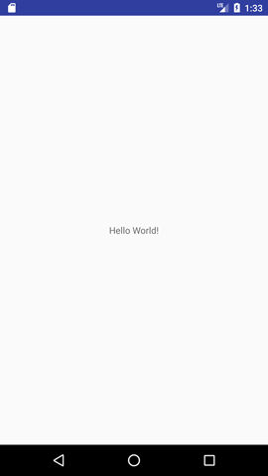

*Try custom settings with the title bar in MainActivity.java file:*

@Override  
**protected void** onCreate(Bundle savedInstanceState) {  
 **super**.onCreate(savedInstanceState);  
  
 requestWindowFeature(Window.***FEATURE_NO_TITLE***);

getSupportActionBar().setTitle(**"SDJ International College"**);  
  
 getSupportActionBar().hide();

**this**.getWindow().setFlags(WindowManager.LayoutParams.***FLAG_FULLSCREEN***,WindowManager.LayoutParams.***FLAG_FULLSCREEN***);

setContentView(R.layout.***activity_main***);  
}

[5.2 screen Orientation (Portrait, Landscape)](https://www.javatpoint.com/android-screen-orientation-example)

### **Android Screen Orientation Example**

The **screenOrientation** is the attribute of activity element. The orientation of android activity can be portrait, landscape, sensor, unspecified etc. You need to define it in the AndroidManifest.xml file.

**Syntax:**

1. **<activity** android:name="package_name.Your_ActivityName"
2. android:screenOrientation="orirntation_type"**>**
3. **</activity>**
4. **<activity** android:name=" example.com.screenorientation.MainActivity"
5. android:screenOrientation="portrait"**>**
6. **</activity>**
7. **<activity** android:name=".SecondActivity"
8. android:screenOrientation="landscape"**>**
9. **</activity>**

The common values for screenOrientation attribute are as follows:

|  |  |
| --- | --- |
| **Value** | **Description** |
| unspecified | It is the default value. In such case, system chooses the orientation. |
| portrait | taller not wider |
| landscape | wider not taller |
| sensor | orientation is determined by the device orientation sensor. |

Android Portrait and Landscape mode screen orientation example

In this example, we will create two activities of different screen orientation. The first activity (MainActivity) will be as "portrait" orientation and second activity (SecondActivity) as "landscape" orientation type.

activity_main.xml

1. **<?xml** version="1.0" encoding="utf-8"**?>**
2. **<android.support.constraint.ConstraintLayout** xmlns:android="http://schemas.android.com/apk/res/android"
3. xmlns:app="http://schemas.android.com/apk/res-auto"
4. xmlns:tools="http://schemas.android.com/tools"
5. android:layout_width="match_parent"
6. android:layout_height="match_parent"
7. tools:context="example.com.screenorientation.MainActivity"**>**

10. **<Button**
11. android:id="@+id/button1"
12. android:layout_width="wrap_content"
13. android:layout_height="wrap_content"
14. android:layout_marginBottom="8dp"
15. android:layout_marginTop="112dp"
16. android:onClick="onClick"
17. android:text="Launch next activity"
18. app:layout_constraintBottom_toBottomOf="parent"
19. app:layout_constraintEnd_toEndOf="parent"
20. app:layout_constraintHorizontal_bias="0.612"
21. app:layout_constraintStart_toStartOf="parent"
22. app:layout_constraintTop_toBottomOf="@+id/editText1"
23. app:layout_constraintVertical_bias="0.613" **/>**
25. **<TextView**
26. android:id="@+id/editText1"
27. android:layout_width="wrap_content"
28. android:layout_height="wrap_content"
29. android:layout_centerHorizontal="true"
30. android:layout_marginEnd="8dp"
31. android:layout_marginStart="8dp"
32. android:layout_marginTop="124dp"
33. android:ems="10"
34. android:textSize="22dp"
35. android:text="This activity is portrait orientation"
36. app:layout_constraintEnd_toEndOf="parent"
37. app:layout_constraintHorizontal_bias="0.502"
38. app:layout_constraintStart_toStartOf="parent"
39. app:layout_constraintTop_toTopOf="parent" **/>**
40. **</android.support.constraint.ConstraintLayout>**

#### **Activity class**

File: MainActivity.java

1. **package** example.com.screenorientation;
3. **import** android.content.Intent;
4. **import** android.support.v7.app.AppCompatActivity;
5. **import** android.os.Bundle;
6. **import** android.view.View;
7. **import** android.widget.Button;
9. **public** **class** MainActivity **extends** AppCompatActivity {
11. Button button1;
12. @Override
13. **protected** **void** onCreate(Bundle savedInstanceState) {
14. **super**.onCreate(savedInstanceState);
15. setContentView(R.layout.activity_main);
17. button1=(Button)findViewById(R.id.button1);
18. }
19. **public** **void** onClick(View v) {
20. Intent intent = **new** Intent(MainActivity.**this**,SecondActivity.**class**);
21. startActivity(intent);
22. }
23. }

#### **activity_second.xml**

File: activity_second.xml

1. **<?xml** version="1.0" encoding="utf-8"**?>**
2. **<android.support.constraint.ConstraintLayout** xmlns:android="http://schemas.android.com/apk/res/android"
3. xmlns:app="http://schemas.android.com/apk/res-auto"
4. xmlns:tools="http://schemas.android.com/tools"
5. android:layout_width="match_parent"
6. android:layout_height="match_parent"
7. tools:context="example.com.screenorientation.SecondActivity"**>**
9. **<TextView**
10. android:id="@+id/textView"
11. android:layout_width="wrap_content"
12. android:layout_height="wrap_content"
13. android:layout_marginEnd="8dp"
14. android:layout_marginStart="8dp"
15. android:layout_marginTop="180dp"
16. android:text="this is landscape orientation"
17. android:textSize="22dp"
18. app:layout_constraintEnd_toEndOf="parent"
19. app:layout_constraintHorizontal_bias="0.502"
20. app:layout_constraintStart_toStartOf="parent"
21. app:layout_constraintTop_toTopOf="parent" **/>**
22. **</android.support.constraint.ConstraintLayout>**

#### **SecondActivity class**

File: SecondActivity.java

1. **package** example.com.screenorientation;
3. **import** android.support.v7.app.AppCompatActivity;
4. **import** android.os.Bundle;
6. **public** **class** SecondActivity **extends** AppCompatActivity {
8. @Override
9. **protected** **void** onCreate(Bundle savedInstanceState) {
10. **super**.onCreate(savedInstanceState);
11. setContentView(R.layout.activity_second);
13. }
14. }

#### **AndroidManifest.xml**

File: AndroidManifest.xml

In AndroidManifest.xml file add the screenOrientation attribute in activity and provides its orientation. In this example, we provide "portrait" orientation for MainActivity and "landscape" for SecondActivity.

1. **<?xml** version="1.0" encoding="utf-8"**?>**
2. **<manifest** xmlns:android="http://schemas.android.com/apk/res/android"
3. package="example.com.screenorientation"**>**
5. **<application**
6. android:allowBackup="true"
7. android:icon="@mipmap/ic_launcher"
8. android:label="@string/app_name"
9. android:roundIcon="@mipmap/ic_launcher_round"
10. android:supportsRtl="true"
11. android:theme="@style/AppTheme"**>**
12. **<activity**
13. android:name="example.com.screenorientation.MainActivity"
14. android:screenOrientation="portrait"**>**
15. **<intent-filter>**
16. **<action** android:name="android.intent.action.MAIN" **/>**
18. **<category** android:name="android.intent.category.LAUNCHER" **/>**
19. **</intent-filter>**
20. **</activity>**
21. **<activity** android:name=".SecondActivity"
22. android:screenOrientation="landscape"**>**
23. **</activity>**
24. **</application>**
26. **</manifest>**

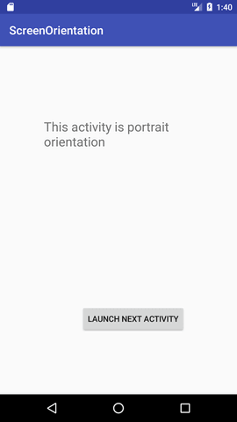

**Change Screen Orientation Programmatically.**

#### **Activity class**

File: MainActivity.java

**public class** MainActivity **extends** AppCompatActivity {  
  
 @Override  
 **protected void** onCreate(Bundle savedInstanceState) {  
 **super**.onCreate(savedInstanceState);  
 setContentView(R.layout.***activity_main***);  
 }  
  
 **public void** onPotraitButtonClick(View view) {  
 setRequestedOrientation(ActivityInfo.***SCREEN_ORIENTATION_PORTRAIT***);  
 }  
  
 **public void** onLandscapeButtonClick(View view) {  
 setRequestedOrientation(ActivityInfo.***SCREEN_ORIENTATION_LANDSCAPE***);  
 }  
  
 **public void** onSensorButtonClick(View view) {  
 setRequestedOrientation(ActivityInfo.***SCREEN_ORIENTATION_SENSOR***);  
 }  
}

#### **Layout File**

File: activity_main.xml

*<?***xml version="1.0" encoding="utf-8"***?>*<**androidx.constraintlayout.widget.ConstraintLayout xmlns:android="http://schemas.android.com/apk/res/android"  
 xmlns:app="http://schemas.android.com/apk/res-auto"  
 xmlns:tools="http://schemas.android.com/tools"  
 android:layout_width="match_parent"  
 android:layout_height="match_parent"  
 tools:context=".MainActivity"**>  
  
 <**TextView  
 android:id="@+id/textView2"  
 android:layout_width="wrap_content"  
 android:layout_height="wrap_content"  
 android:layout_marginTop="32dp"  
 android:text="Change Screen Orientation"  
 app:layout_constraintLeft_toLeftOf="parent"  
 app:layout_constraintRight_toRightOf="parent"  
 app:layout_constraintTop_toTopOf="parent"** />  
  
 <**Button  
 android:id="@+id/button"  
 android:layout_width="wrap_content"  
 android:layout_height="wrap_content"  
 android:layout_marginTop="32dp"  
 android:onClick="onPotraitButtonClick"  
 android:text="Potrait Orientation"  
 app:layout_constraintEnd_toEndOf="parent"  
 app:layout_constraintStart_toStartOf="parent"  
 app:layout_constraintTop_toBottomOf="@+id/textView2"** />  
  
 <**Button  
 android:id="@+id/button2"  
 android:layout_width="wrap_content"  
 android:layout_height="wrap_content"  
 android:layout_marginTop="32dp"  
 android:onClick="onLandscapeButtonClick"  
 android:text="Landscape Orientation"  
 app:layout_constraintEnd_toEndOf="parent"  
 app:layout_constraintStart_toStartOf="parent"  
 app:layout_constraintTop_toBottomOf="@+id/button"** />  
  
 <**Button  
 android:id="@+id/button3"  
 android:layout_width="wrap_content"  
 android:layout_height="wrap_content"  
 android:layout_marginTop="32dp"  
 android:onClick="onSensorButtonClick"  
 android:text="Sensor Orientation"  
 app:layout_constraintEnd_toEndOf="parent"  
 app:layout_constraintStart_toStartOf="parent"  
 app:layout_constraintTop_toBottomOf="@+id/button2"** />  
  
</**androidx.constraintlayout.widget.ConstraintLayout**>

Output:

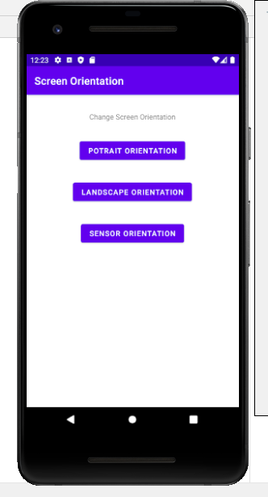 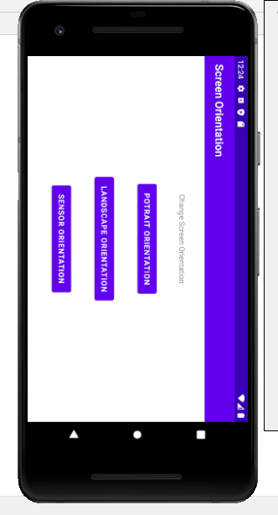

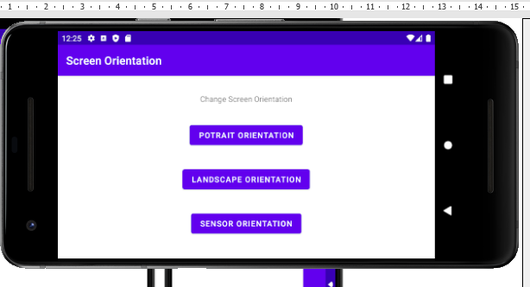

[5.3 Form Widget Palette](https://www.javatpoint.com/android-working-with-button)

5.3.1 Placing text fields and Button

5.3.2 Button onClick event

# **Android Button Example**

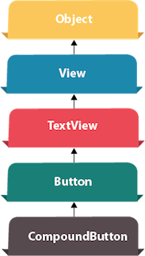

Android Button represents a push-button. The android.widget.Button is subclass of TextView class and CompoundButton is the subclass of Button class.

There are different types of buttons in android such as RadioButton, ToggleButton, CompoundButton etc.

## Android Button Example with Listener

Here, we are going to create two textfields and one button for sum of two numbers. If user clicks button, sum of two input values is displayed on the Toast.

We can perform action on button using different types such as calling listener on button or adding onClick property of button in activity's xml file.

1. button.setOnClickListener(new View.OnClickListener() {
2. @Override
3. public void onClick(View view) {
4. //code
5. }
6. });
7. **<Button**
8. android:onClick="methodName"
9. **/>**

### **Drag the component or write the code for UI in activity_main.xml**

First of all, drag 2 textfields from the Text Fields palette and one button from the Form Widgets palette as shown in the following figure.

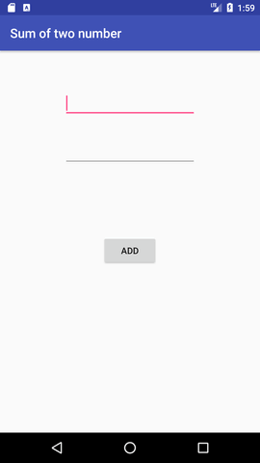

The generated code for the ui components will be like this:

*File: activity_main.xml*

1. **<?xml** version="1.0" encoding="utf-8"**?>**
2. **<RelativeLayout** xmlns:android="http://schemas.android.com/apk/res/android"
3. xmlns:app="http://schemas.android.com/apk/res-auto"
4. xmlns:tools="http://schemas.android.com/tools"
5. android:layout_width="match_parent"
6. android:layout_height="match_parent"
7. tools:context="example..com.sumoftwonumber.MainActivity"**>**
9. **<EditText**
10. android:id="@+id/editText1"
11. android:layout_width="wrap_content"
12. android:layout_height="wrap_content"
13. android:layout_alignParentTop="true"
14. android:layout_centerHorizontal="true"
15. android:layout_marginTop="61dp"
16. android:ems="10"
17. android:inputType="number"
18. tools:layout_editor_absoluteX="84dp"
19. tools:layout_editor_absoluteY="53dp" **/>**
21. **<EditText**
22. android:id="@+id/editText2"
23. android:layout_width="wrap_content"
24. android:layout_height="wrap_content"
25. android:layout_below="@+id/editText1"
26. android:layout_centerHorizontal="true"
27. android:layout_marginTop="32dp"
28. android:ems="10"
29. android:inputType="number"
30. tools:layout_editor_absoluteX="84dp"
31. tools:layout_editor_absoluteY="127dp" **/>**
33. **<Button**
34. android:id="@+id/button"
35. android:layout_width="wrap_content"
36. android:layout_height="wrap_content"
37. android:layout_below="@+id/editText2"
38. android:layout_centerHorizontal="true"
39. android:layout_marginTop="109dp"
40. android:text="ADD"
41. tools:layout_editor_absoluteX="148dp"
42. tools:layout_editor_absoluteY="266dp" **/>**
43. **</RelativeLayout>**

### **Activity class**

Now write the code to display the sum of two numbers.

*File: MainActivity.java*

1. **package** example..com.sumoftwonumber;
3. **import** android.support.v7.app.AppCompatActivity;
4. **import** android.os.Bundle;
5. **import** android.view.View;
6. **import** android.widget.Button;
7. **import** android.widget.EditText;
8. **import** android.widget.Toast;
10. **public** **class** MainActivity **extends** AppCompatActivity {
11. **private** EditText edittext1, edittext2;
12. **private** Button buttonSum;
14. @Override
15. **protected** **void** onCreate(Bundle savedInstanceState) {
16. **super**.onCreate(savedInstanceState);
17. setContentView(R.layout.activity_main);
19. addListenerOnButton();
20. }
22. **public** **void** addListenerOnButton() {
23. edittext1 = (EditText) findViewById(R.id.editText1);
24. edittext2 = (EditText) findViewById(R.id.editText2);
25. buttonSum = (Button) findViewById(R.id.button);
27. buttonSum.setOnClickListener(**new** View.OnClickListener() {
28. @Override
29. **public** **void** onClick(View view) {
30. String value1=edittext1.getText().toString();
31. String value2=edittext2.getText().toString();
32. **int** a=Integer.parseInt(value1);
33. **int** b=Integer.parseInt(value2);
34. **int** sum=a+b;
35. Toast.makeText(getApplicationContext(),String.valueOf(sum), Toast.LENGTH_LONG).show();
36. }
37. });
38. }
39. }

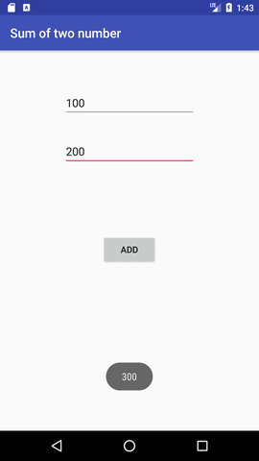

[5.4 Displaying Notification:](https://www.javatpoint.com/android-toast-example)

5.4.1 Toast Class

5.4.2 Displaying message on Toast

# **Android Toast Example**

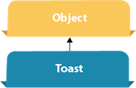

Andorid Toast can be used to display information for the short period of time. A toast contains message to be displayed quickly and disappears after sometime.

The android.widget.Toast class is the subclass of java.lang.Object class.

You can also create custom toast as well for example toast displaying image. You can visit next page to see the code for custom toast.

## Toast class

Toast class is used to show notification for a particular interval of time. After sometime it disappears. It doesn't block the user interaction.

#### **Constants of Toast class**

There are only 2 constants of Toast class which are given below.

|  |  |
| --- | --- |
| **Constant** | **Description** |
| public static final int LENGTH_LONG | displays view for the long duration of time. |
| public static final int LENGTH_SHORT | displays view for the short duration of time. |

#### **Methods of Toast class**

The widely used methods of Toast class are given below.

|  |  |
| --- | --- |
| **Method** | **Description** |
| public static Toast makeText(Context context, CharSequence text, int duration) | makes the toast containing text and duration. |
| public void show() | displays toast. |
| public void setMargin (float horizontalMargin, float verticalMargin) | changes the horizontal and vertical margin difference. |

Android Toast Example

1. Toast.makeText(getApplicationContext(),"Hello Javatpoint",Toast.LENGTH_SHORT).show();

Another code:

1. Toast toast=Toast.makeText(getApplicationContext(),"Hello Javatpoint",Toast.LENGTH_SHORT);
2. toast.setMargin(50,50);
3. toast.show();

Here, getApplicationContext() method returns the instance of Context.

Full code of activity class displaying Toast

Let's see the code to display the toast.

*File: MainActivity.java*

1. **package** example..com.toast;
3. **import** android.support.v7.app.AppCompatActivity;
4. **import** android.os.Bundle;
5. **import** android.widget.Toast;
7. **public** **class** MainActivity **extends** AppCompatActivity {
9. @Override
10. **protected** **void** onCreate(Bundle savedInstanceState) {
11. **super**.onCreate(savedInstanceState);
12. setContentView(R.layout.activity_main);
14. //Displaying Toast with Hello Javatpoint message
15. Toast.makeText(getApplicationContext(),"Hello Javatpoint",Toast.LENGTH_SHORT).show();
16. }
17. }

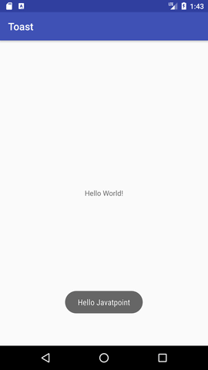

[5.5 ToggleButton:](https://www.javatpoint.com/android-togglebutton-example)

5.5.1 ToggleButton Attributes:(textOff, textOn)

5.5.2 Event methods : getTextOff(), getTextOn(), setChecked()

# **Android ToggleButton Example**

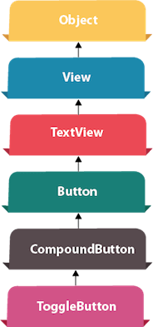

**Android Toggle Button** can be used to display checked/unchecked (On/Off) state on the button.

It is beneficial if user have to change the setting between two states. It can be used to On/Off Sound, Wifi, Bluetooth etc.

Since Android 4.0, there is another type of toggle button called switch that provides slider control.

Android ToggleButton and Switch both are the subclasses of CompoundButton class.

## Android ToggleButton class

ToggleButton class provides the facility of creating the toggle button.

### **XML Attributes of ToggleButton class**

The 3 XML attributes of ToggleButton class.

|  |  |
| --- | --- |
| **XML Attribute** | **Description** |
| android:disabledAlpha | The alpha to apply to the indicator when disabled. |
| android:textOff | The text for the button when it is not checked. |
| android:textOn | The text for the button when it is checked. |

### **Methods of ToggleButton class**

The widely used methods of ToggleButton class are given below.

|  |  |
| --- | --- |
| **Method** | **Description** |
| CharSequence getTextOff() | Returns the text when button is not in the checked state. |
| CharSequence getTextOn() | Returns the text for when button is in the checked state. |
| void setChecked(boolean checked) | Changes the checked state of this button. |

## Android ToggleButton Example

#### **activity_main.xml**

Drag two toggle button and one button for the layout. Now the activity_main.xml file will look like this:

*File: activity_main.xml*

1. **<?xml** version="1.0" encoding="utf-8"**?>**
2. **<android.support.constraint.ConstraintLayout** xmlns:android="http://schemas.android.com/apk/res/android"
3. xmlns:app="http://schemas.android.com/apk/res-auto"
4. xmlns:tools="http://schemas.android.com/tools"
5. android:layout_width="match_parent"
6. android:layout_height="match_parent"
7. tools:context="example..com.togglebutton.MainActivity"**>**
9. **<ToggleButton**
10. android:id="@+id/toggleButton"
11. android:layout_width="wrap_content"
12. android:layout_height="wrap_content"
13. android:layout_marginLeft="8dp"
14. android:layout_marginTop="80dp"
15. android:text="ToggleButton"
16. android:textOff="Off"
17. android:textOn="On"
18. app:layout_constraintEnd_toStartOf="@+id/toggleButton2"
19. app:layout_constraintStart_toStartOf="parent"
20. app:layout_constraintTop_toTopOf="parent" **/>**
22. **<ToggleButton**
23. android:id="@+id/toggleButton2"
24. android:layout_width="wrap_content"
25. android:layout_height="wrap_content"
26. android:layout_marginRight="60dp"
27. android:layout_marginTop="80dp"
28. android:text="ToggleButton"
29. android:textOff="Off"
30. android:textOn="On"
31. app:layout_constraintEnd_toEndOf="parent"
32. app:layout_constraintTop_toTopOf="parent" **/>**
34. **<Button**
35. android:id="@+id/button"
36. android:layout_width="wrap_content"
37. android:layout_height="wrap_content"
38. android:layout_marginBottom="144dp"
39. android:layout_marginLeft="148dp"
40. android:text="Submit"
41. app:layout_constraintBottom_toBottomOf="parent"
42. app:layout_constraintStart_toStartOf="parent" **/>**
43. **</android.support.constraint.ConstraintLayout>**

#### **Activity class**

Let's write the code to check which toggle button is ON/OFF.

*File: MainActivity.java*

1. **package** example..com.togglebutton;
3. **import** android.support.v7.app.AppCompatActivity;
4. **import** android.os.Bundle;
5. **import** android.view.View;
6. **import** android.widget.Button;
7. **import** android.widget.Toast;
8. **import** android.widget.ToggleButton;
10. **public** **class** MainActivity **extends** AppCompatActivity {
11. **private** ToggleButton toggleButton1, toggleButton2;
12. **private** Button buttonSubmit;
13. @Override
14. **protected** **void** onCreate(Bundle savedInstanceState) {
15. **super**.onCreate(savedInstanceState);
16. setContentView(R.layout.activity_main);
18. addListenerOnButtonClick();
19. }
21. **public** **void** addListenerOnButtonClick(){
22. //Getting the ToggleButton and Button instance from the layout xml file
23. toggleButton1=(ToggleButton)findViewById(R.id.toggleButton);
24. toggleButton2=(ToggleButton)findViewById(R.id.toggleButton2);
25. buttonSubmit=(Button)findViewById(R.id.button);
27. //Performing action on button click
28. buttonSubmit.setOnClickListener(**new** View.OnClickListener(){
30. @Override
31. **public** **void** onClick(View view) {
32. StringBuilder result = **new** StringBuilder();
33. result.append("ToggleButton1 : ").append(toggleButton1.getText());
34. result.append("\nToggleButton2 : ").append(toggleButton2.getText());
35. //Displaying the message in toast
36. Toast.makeText(getApplicationContext(), result.toString(),Toast.LENGTH_LONG).show();
37. }
39. });
41. }
42. }

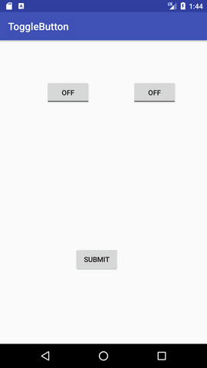 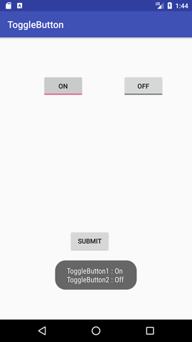

[5.6 CheckBox:](https://www.javatpoint.com/android-checkbox-example)

5.6.1 Event methods: isChecked(), setChecked()

# **Android CheckBox Example**

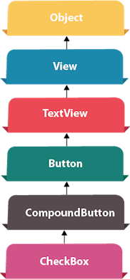

**Android CheckBox** is a type of two state button either checked or unchecked.

There can be a lot of usage of checkboxes. For example, it can be used to know the hobby of the user, activate/deactivate the specific action etc.

Android CheckBox class is the subclass of CompoundButton class.

## Android CheckBox class

The android.widget.CheckBox class provides the facility of creating the CheckBoxes.

#### Methods of CheckBox class

There are many inherited methods of View, TextView, and Button classes in the CheckBox class. Some of them are as follows:

|  |  |
| --- | --- |
| **Method** | **Description** |
| public boolean isChecked() | Returns true if it is checked otherwise false. |
| public void setChecked(boolean status) | Changes the state of the CheckBox. |

## Android CheckBox Example

#### **activity_main.xml**

Drag the three checkboxes and one button for the layout. Now the activity_main.xml file will look like this:

*File: activity_main.xml*

1. **<?xml** version="1.0" encoding="utf-8"**?>**
2. **<android.support.constraint.ConstraintLayout** xmlns:android="http://schemas.android.com/apk/res/android"
3. xmlns:app="http://schemas.android.com/apk/res-auto"
4. xmlns:tools="http://schemas.android.com/tools"
5. android:layout_width="match_parent"
6. android:layout_height="match_parent"
7. tools:context="example..com.checkbox.MainActivity"**>**

10. **<CheckBox**
11. android:id="@+id/checkBox"
12. android:layout_width="wrap_content"
13. android:layout_height="wrap_content"
14. android:layout_marginLeft="144dp"
15. android:layout_marginTop="68dp"
16. android:text="Pizza"
17. app:layout_constraintStart_toStartOf="parent"
18. app:layout_constraintTop_toTopOf="parent" **/>**
20. **<CheckBox**
21. android:id="@+id/checkBox2"
22. android:layout_width="wrap_content"
23. android:layout_height="wrap_content"
24. android:layout_marginLeft="144dp"
25. android:layout_marginTop="28dp"
26. android:text="Coffee"
27. app:layout_constraintStart_toStartOf="parent"
28. app:layout_constraintTop_toBottomOf="@+id/checkBox" **/>**
30. **<CheckBox**
31. android:id="@+id/checkBox3"
32. android:layout_width="wrap_content"
33. android:layout_height="wrap_content"
34. android:layout_marginLeft="144dp"
35. android:layout_marginTop="28dp"
36. android:text="Burger"
37. app:layout_constraintStart_toStartOf="parent"
38. app:layout_constraintTop_toBottomOf="@+id/checkBox2" **/>**
40. **<Button**
41. android:id="@+id/button"
42. android:layout_width="wrap_content"
43. android:layout_height="wrap_content"
44. android:layout_marginLeft="144dp"
45. android:layout_marginTop="184dp"
46. android:text="Order"
47. app:layout_constraintStart_toStartOf="parent"
48. app:layout_constraintTop_toBottomOf="@+id/checkBox3" **/>**
50. **</android.support.constraint.ConstraintLayout>**

#### **Activity class**

Let's write the code to check which toggle button is ON/OFF.

*File: MainActivity.java*

1. **package** example..com.checkbox;
3. **import** android.support.v7.app.AppCompatActivity;
4. **import** android.os.Bundle;
5. **import** android.view.View;
6. **import** android.widget.Button;
7. **import** android.widget.CheckBox;
8. **import** android.widget.Toast;
10. **public** **class** MainActivity **extends** AppCompatActivity {
11. CheckBox pizza,coffe,burger;
12. Button buttonOrder;
13. @Override
14. **protected** **void** onCreate(Bundle savedInstanceState) {
15. **super**.onCreate(savedInstanceState);
16. setContentView(R.layout.activity_main);
17. addListenerOnButtonClick();
18. }
19. **public** **void** addListenerOnButtonClick(){
20. //Getting instance of CheckBoxes and Button from the activty_main.xml file
21. pizza=(CheckBox)findViewById(R.id.checkBox);
22. coffe=(CheckBox)findViewById(R.id.checkBox2);
23. burger=(CheckBox)findViewById(R.id.checkBox3);
24. buttonOrder=(Button)findViewById(R.id.button);
26. //Applying the Listener on the Button click
27. buttonOrder.setOnClickListener(**new** View.OnClickListener(){
29. @Override
30. **public** **void** onClick(View view) {
31. **int** totalamount=0;
32. StringBuilder result=**new** StringBuilder();
33. result.append("Selected Items:");
34. **if**(pizza.isChecked()){
35. result.append("\nPizza 100Rs");
36. totalamount+=100;
37. }
38. **if**(coffe.isChecked()){
39. result.append("\nCoffe 50Rs");
40. totalamount+=50;
41. }
42. **if**(burger.isChecked()){
43. result.append("\nBurger 120Rs");
44. totalamount+=120;
45. }
46. result.append("\nTotal: "+totalamount+"Rs");
47. //Displaying the message on the toast
48. Toast.makeText(getApplicationContext(), result.toString(), Toast.LENGTH_LONG).show();
49. }
51. });
52. }
53. }

